Stage 1 - Python Programming or TypeScript
Stage 2 - Web Automation and API Automation (Playwright)
Stage 3 - Hybrid Framework (Data Driven Framework, Keyword Driven Framework, Page Object Model, Testing Framework)
Stage 4 - Git & Jenkins
Stage 5 - Gen AI features

Break: 11 to 11:15 AM IST
https://codeshare.io/del123

TypeScript Playwright - https://github.com/balaji-githubstore/typescript-playwright-deloitte-aug-2026.git

Typescript Framework:
https://github.com/balaji-githubstore/typescript-playwright-framework-deloitte-aug-2026.git

Python Playwright - https://github.com/balaji-githubstore/python-playwright-deloitte-aug-2026.git

Python Pytest Framework -
https://github.com/balaji-githubstore/python-playwright-pytest-framework-deloitte-aug-2026.git

Python Programming
- Installation
  - Python - https://www.python.org/
- Add Python to environment variable - Path
C:\Program Files\Python314
C:\Program Files\Python314\Scripts
- Verify Python in command prompt
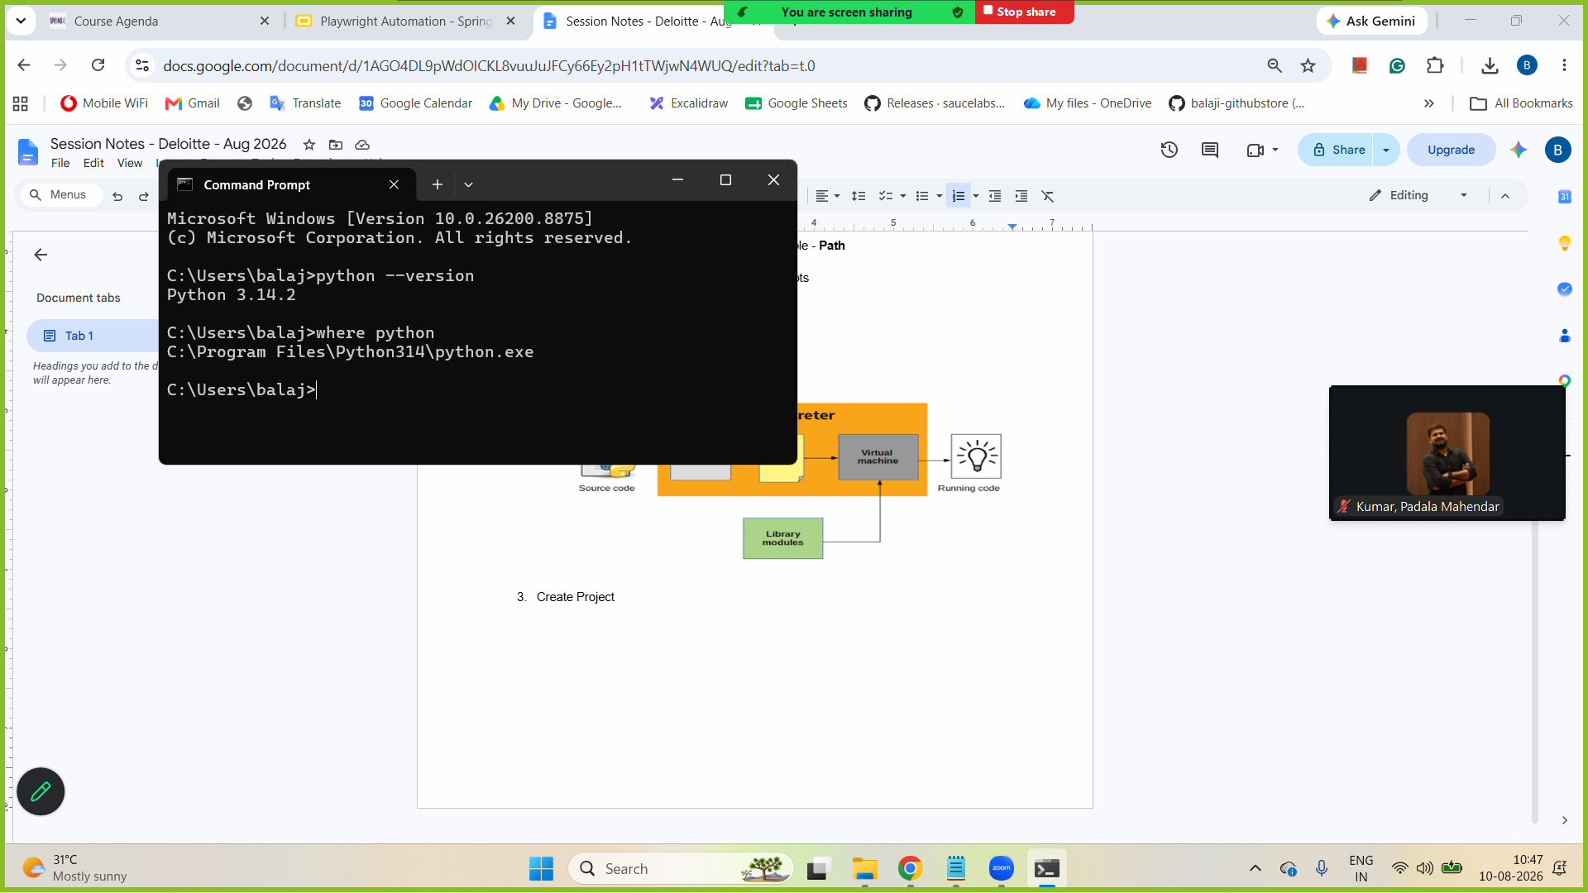
  - VS Code
    - Add Python extension
  - PyCharm

- Architecture of Python
Source code (.py)
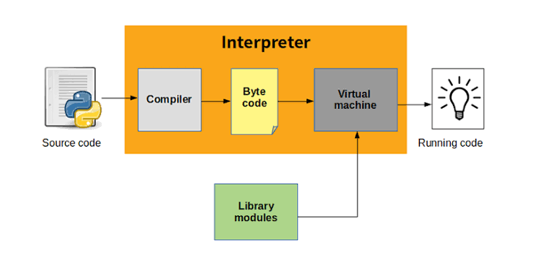

- UpperCamelCase - MyFirstProject
lowercase_with_underscore - my_first_project

- Create Project (Structure of a Python project)
Project
Package - (lowercase_with_underscore)
Module (.py) -( lowercase_with_underscore )
Variables and methods (lowercase_with_underscore)
Class (UpperCamelCase)
Variables and methods

- Set up the virtual environment for the current project
- Datatypes
  - Numeric
    - Int
    - Float
  - Sequence datatypes
    - String
    - List
    - Tuple
  - Boolean
  - Dictionary (key-value)
- Conditional statements
  - If
- Iterative statements
  - For loop
  - Advanced for loop (for each)
  - While
  - Do while
- Methods - Building block of the program
  - Reuse
  - Maintenance
- VS Code - launch.json (Run configuration for vs code)
- Debugging
  - Continue
  - Stop
  - Step into
  - Step over
- Variable
  - Static variable
  - Non-static variable

How to create static variables and non-static variables?

How to call a static variable?
ClassName.VariableName
How to call a non-static variable?
- Create object
- Use objref.VariableName
- Methods
  - Static methods
  - Non-static methods
How to call a static methods ?
ClassName.MethodName
How to call a non-static methods ?
  - Create object
  - Use objref.MethodName

- Class and Object
Class - A class is a template or blueprint or type from which objects are created
Object -
- An object is an instance of a class
- Every object has its own state (non-static variable) and behaviour (non-static method)
- Constructor
  - Constructor - it’s a kind of method that gets called whenever objects are created
  - We can create a constructor
    - Without argument
    - With arguments
  - If the constructor is with arguments, then during object creation we need to call that constructor only.
- Access modifier
  - Private - accessible within the class (use __)
  - Protected - accessible within the class and child classes (use _)
  - Public - accessible anywhere
- Encapsulation is a fundamental concept in OOP that combines data (attributes) and methods that work with that data, while simultaneously restricting direct access to the inner workings of that object.
  - Protect all variables and permit updating either in the constructor or a property/method
@property
def emp_salary(self):
return self.__emp_salary

# set property - write
@emp_salary.setter
def emp_salary(self, value):
if value>0:
self.__emp_salary = value
else:
self.__emp_salary=0

Playwright
- Install Playwright
pip install playwright
- playwright - launch browser understanding
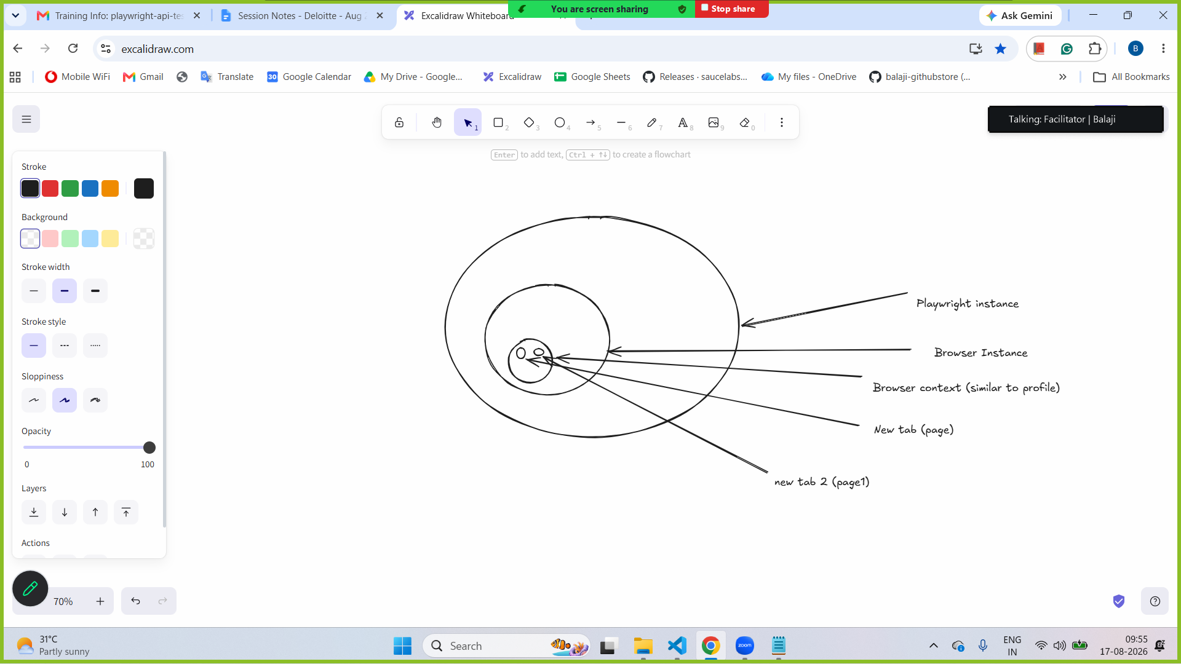
- Launch browser
  - Playwright instance → Browser instance → Browser context → Page
- Click, Type, Select
- Inspect → tag name, attribute, text or not
- Locators
  - XPath
  - CSS
  - Text
    - page.locator("text=Allow all").click()
  - tagname:has-text
page.locator("button:has-text('Allow all')").click()

  - tagname & has-text with locator
page.locator("button",has_text='Allow all').click()

- Dropdown
  - With Select tag
    - Label
    - Value
    - Index - starts at 0
page.locator("xpath=//select[@id='Form_getForm_Country']").select_option(label="India")

  - Without select tag
    - Using click()
- Autowait
  - By default, a necessary auto-wait condition will be check for 30s when any operation is done.
  - https://playwright.dev/docs/actionability
- Multiple tabs/windows

- Frame - HTML embedded into another HTML
  - Even though the XPath is correct, we get a no locator found error
  - Check for tag name - iframe or frame
  - Get the frame locator and then do the operation

- Alert
  - JavaScript alert - Playwright will auto-handle the alert.
  - page.on → event method to override the default behaviour of handling alert by Playwright.

- Upload (any one option)
  - page.locator().set_file()
# option 1 -- check for //input[@type='file']
page.locator("xpath=//input[@type='file']").set_input_files(r"D:\Mine\Balaji Dinakaran Trainer Profile AI 2026.pdf")

  - page.expect_filechooser()
# option 2 - page.expect_filechooser()
with page.expect_file_chooser() as file_chooser_info:
page.locator("xpath=//span[text()='Select PDF file']").click()
file_chooser=file_chooser_info.value

file_chooser.set_files(r"D:\Mine\Balaji Dinakaran Trainer Profile AI 2026.pdf")

  - page.on(“filechooser”) → avoid event register
# option 3 - page.on(“filechooser”) - registering the event that runs when filechooser comes into picture
page.on("filechooser",lambda filechooser:filechooser.set_files(r"D:\Mine\Balaji Dinakaran Trainer Profile AI 2026.pdf"))

# click on element that opens filechooser
page.locator("xpath=//span[text()='Select PDF file']").click()

- Download
  - page.expect_download
  - page.on(“download”)
https://www.selenium.dev/downloads/

- Shadowroot
  - Only works with CSS selector
  - All locators in Playwright by default work with elements in Shadow DOM. except XPath

- ChromeOptions (args) - pre-setting to browser notification
  - https://developer.chrome.com/docs/chromedriver/capabilities
let browser=await chromium.launch({channel:"msedge",headless:false,args:["--disable-notifications"]})
- Locators and, or , nth
actual_error=page.locator("div[class*='wes:text-red wes:transition-colors']").and_(page.locator("div:has-text('Enter valid phone number.')")).inner_text()
print(actual_error)

actual_error=page.locator("div:has-text('Enter valid phone number.')").nth(12).inner_text()
print(actual_error)

—-------------------------------------------------------------------------------------------------------

API testing using Postman (manual testing) - pre-requisite

API Automation
- Swagger document
  - Base URL - "https://petstore.swagger.io/v2/"
  - Check resource for each methods
  - Understand the resources
- GET request - fetch the records
  - Path parameter
  - Query string
- Find Pet By ID → example for path parameter
  - Base url
  - Resource → /pet/{petId}
- Find Pet By Status → example for Query string
- Post - Add pet
- Put - Update pet
- Delete

—-------------------------------------------------------------------------------------------------

Framework
- Test Framework (Pytest)
- Data Driven Framework (Separating the test methods from test data - excel, csv, json)
- Page Object Model - (For managing the web elements)

Keyword Driven Framework - For effective maintenance of Playwright scripts

Python framework packages

tests → contains only test classes and test methods
base → contains browser config & playwright keywords
page → Page class and page methods
utilities → keeps test data, code for handling Excel, CSV, JSON.

test_data → folder to contains files.

Steps to create a framework
- Set up pytest extensions
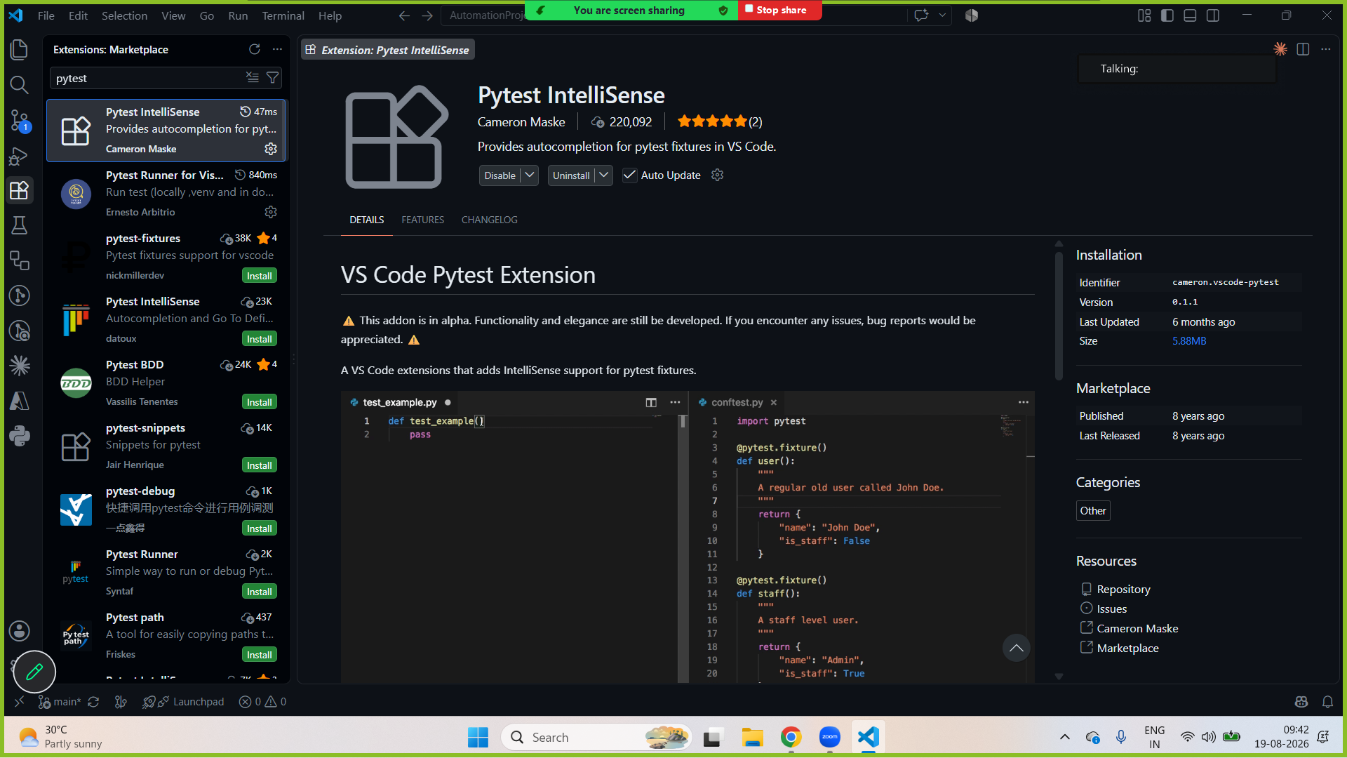
- Create project
- Configure virtual env
- Install → pip install pytest-playwright

- Create or update
pip freeze > requirements.txt
- On clone or download - use the command below to install libraries
pip install -r requirements.txt
- Create a tests folder and then a test module (.py)
- Create TestClass and test_methods
- Every test method should have at least one assertion. Assertions decides wether the test is passed or failed.
- Browser configuration
- Fixture scopes
Fixtures are created when first requested by a test, and are destroyed based on their scope:
  - function: the default scope, the fixture is destroyed at the end of the test.
    - Runs before and after each test methods
  - class: the fixture is destroyed during teardown of the last test in the class.
  - module: the fixture is destroyed during teardown of the last test in the module.
  - package: the fixture is destroyed during teardown of the last test in the package where the fixture is defined, including sub-packages and sub-directories within it.
  - session: the fixture is destroyed at the end of the test session. (one in the beginning and at the end)
    - Run at start of the project execution
    - Run after executing all the tests at the end

- Data Driven Framework - Separating the test method and test data
- Pytest parameterize → helps to run one test with multiple sets of test data
  - Add necessary parameters for test methods and use them.
  - Supply the test set of data using pytest parameterize
@pytest.mark.parametrize("username, password, expected_error", [
["saul", "saul123", "Invalid credentials"],
["kim", "kim123", "Invalid credentials"]
])

- Create utilities and add test data under data_source.py
- CSV read
  - Install - pip install pandas
- Excel read
  - Install -
    - pip install pandas
    - pip install openpyxl
- Data Driven Framework using CSV and Excel
- Page Object Model - Design Pattern

- Readability
- Maintenance
- Reusability
To implement:
  - For each web page, we need to create a class - Page Class
  - Operations happen through methods - Page methods
  - Add the object repository (locators) at the class level or in a different file.

- For logs and screenshots → conftest.py
- Trace - Playwright - useful feature for debugging (Trace viewer)
  - To check the trace zip file
npx playwright show-trace .\traces\test_trace.zip

Not part of the framework:

- Codegen → help to generate the automation work using browser screen recording.
Install → nodejs -> https://nodejs.org/en/download
Install playwright —> npm install -g playwright@latest
Install Playwright browsers —>npx playwright install
Codegen→ npx playwright codegen https://www.google.com/

—---------------------------------------
- Github copilot
  - agents → Ask, agent, plan
  - Ask
    - You ask Copilot a direct question or request
    - Work like ChatGPT inside your IDE
    - When to use?
      - Explain the code
      - Generate a small function
      - Fix the error
      - Write SQL queries

  - Agent
    - Copilot becomes an AI engineer inside your project (AI Agent)
    - When to use?
      - Create/edit/delete files s
      - Navigate folders
      - Refactor code
      - More powerful than ask
    - What happens?
      - Analyze the project
      - Understand dependencies
      - Modify multiple files
      - Update imports
      - Execute changes

  - Plan
- What is it?
    - Creates a detailed action plan (prompt.md) before making changes.
    - It will show
      - What files will be edited?
      - What code changes will be applied?
      - What new files will be created?
      - You manually approve it before executed

- When to use it?
  - Big refactors
  - Multi-file changes
  - Risky operations
  - Setting up the framework

- GitHub Copilot agents
  - Custom agent

- Playwright agents - https://playwright.dev/docs/test-agents
  - Run → npx playwright init-agents --loop=vscode
- Playwright MCP
  - User gives instruction
  - LLM understands the request
  - LLM will get MCP help to access tools (Playwright, Selenium)
  - LLM gets the necessary details
  - Output → otherwise agent loop happens until LLM able to decide output

- Instead of MCP, ask LLM to use CLI –
  - Playwright CLI – https://github.com/microsoft/playwright-cli
  - npm install -g @playwright/cli@latest
  - Set up skills for your project
    - playwright-cli install --skills

Prompt
Requirements:
- Implement Page object model
- Separate folders: tests, pages, locators, utils, config
- Playwright browser configuration
- Logging using the Python logging module
- Screenshots capture on failure
- Config management using JSON for URL, browser, timeouts, and other config details
Create a step-by-step plan.md including files to be created and changes to be made before implementation

Git - https://git-scm.com/
Git is a free and open source distributed version control system.

Architecture of git

Project (on local machine) → local repository (on local machine) → remote repository (GitHub, Bitbucket, AWS CodeCommit, GitLab)

Git → Modified - stage - commit

- Initialize local repo (.git folder in project home directory)
- Stage the file
- Commit with message → update the local repository
- Register remote URL
- Git push → update the remote repository

B1-no-page-object - created branch at Aug 21, 2026 at 9:46 AM (it created a copy from the existing checkout branch(main))

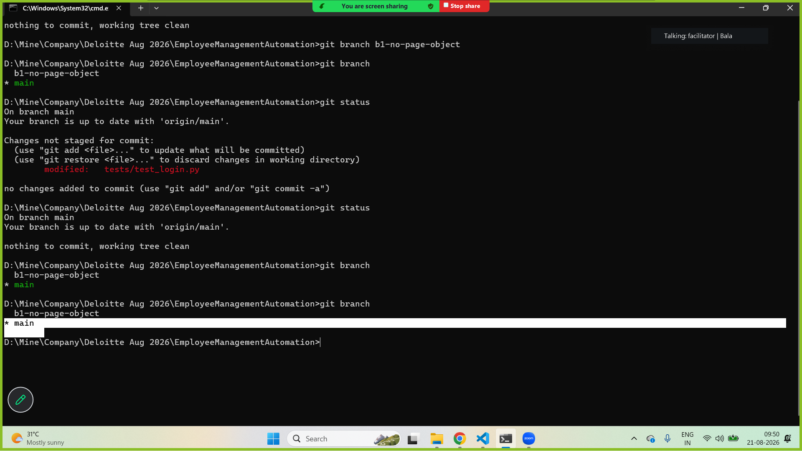

—-----------------------------------

Typescript
- TypeScript -
  - Superset of JavaScript
  - TypeScript - adds types to JavaScript and helps to avoid bugs in run time.
  - TypeScript - also implements future features of JavaScript.

- Datatypes
  - Number, String, boolean
  - Any, unknown (check type before using it), union
  - Array [], object {}
  - Tuples (fixed set of collection with fixed datatypes)

- Architecture of TypeScript
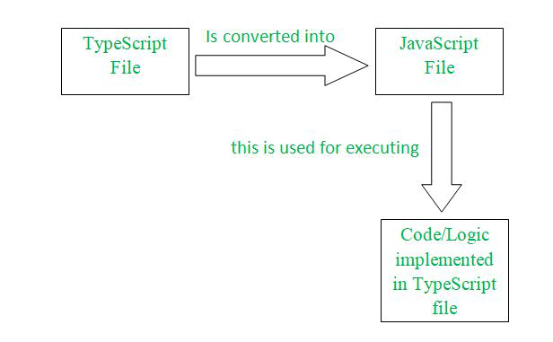
- Installation
  - Install Nodejs
- TypeScript project setup
  - npm init -y
    - Update package.json → "type": "module"
  - npm install -D typescript ts-node @types/node
  - npx tsc --init
- Constructor
  - Constructor - it’s a kind of method that gets called whenever objects are created
  - We can create a constructor
    - Without argument
    - With arguments
  - If the constructor is with arguments, then during object creation we need to call that constructor only.
- Access modifier
  - Private - accessible within the class
  - Protected - accessible within the class and child class
  - Public - accessible anywhere
- Get and set property
private salary: number;
//read
public get getSalary(): number {
return this.salary;
}

//write
public set setSalary(salary: number) {
if (salary > 0) {
this.salary = salary;
}
else {
this.salary = 0;
}
}

- Installation
npm install -D playwright
- Launch browser
  - Playwright instance → Browser instance → Browser context → Page
- Click, Type, Select
- Inspect → tag name, attribute, text or not
- Locators
  - XPath
  - CSS
- Dropdown
  - With Select tag
    - Label
    - Value
    - Index - starts at 0
page.locator("xpath=//select[@id='Form_getForm_Country']").select_option(label="India")

  - Without select tag
    - Using click()
- Autowait
  - By default, a necessary auto-wait condition will be check for 30s when any operation is done.
  - https://playwright.dev/docs/actionability
- Multiple tabs/windows

- Frame - HTML embedded into another HTML
  - Even though the XPath is correct, we get a no locator found error
  - Check for tag name - iframe or frame
  - Get the frame locator and then do the operation

- Alert
  - JavaScript alert - Playwright will auto-handle the alert.
- Upload (any option)
  - page.locator().setInputFiles()
// # option 1 -- check for //input[@type='file']
await page.locator("xpath=//input[@type='file']").setInputFiles("D:\\Mine\\Balaji Dinakaran Trainer Profile AI 2026.pdf")

  - page.waitForEvent("fileChooser")
// # option 2 - page.waitForEvent()
let filechooserInfo=page.waitForEvent("filechooser")
await page.locator("xpath=//span[text()='Select PDF file']").click()
let filechooser=await filechooserInfo

filechooser.setFiles("D:\\Mine\\Balaji Dinakaran Trainer Profile AI 2026.pdf")

  - page.on(“filechooser”)
// # option 3 - page.on(“filechooser”)
page.on("filechooser",async filechooser=>{
await filechooser.setFiles("D:\\Mine\\Balaji Dinakaran Trainer Profile AI 2026.pdf")
})

await page.locator("xpath=//span[text()='Select PDF file']").click()

- Download
  - page.waitForEvent("download")
  - page.on(“download”)
- Shadowroot
  - Use only css selector
- ChromeOptions (args) - pre-setting to browser notification
  - https://developer.chrome.com/docs/chromedriver/capabilities
let browser=await chromium.launch({channel:"msedge",headless:false,args:["--disable-notifications"]})

TypeScript Playwright framework
- Create project
- TypeScript Playwright test project setup
  - npm init -y
    - Update package.json → "type": "module"
  - npm install -D typescript ts-node @types/node
  - npx tsc --init
  - npm install -D @playwright/test@latest
  - npx playwright install --with-deps
  - npm init playwright@latest
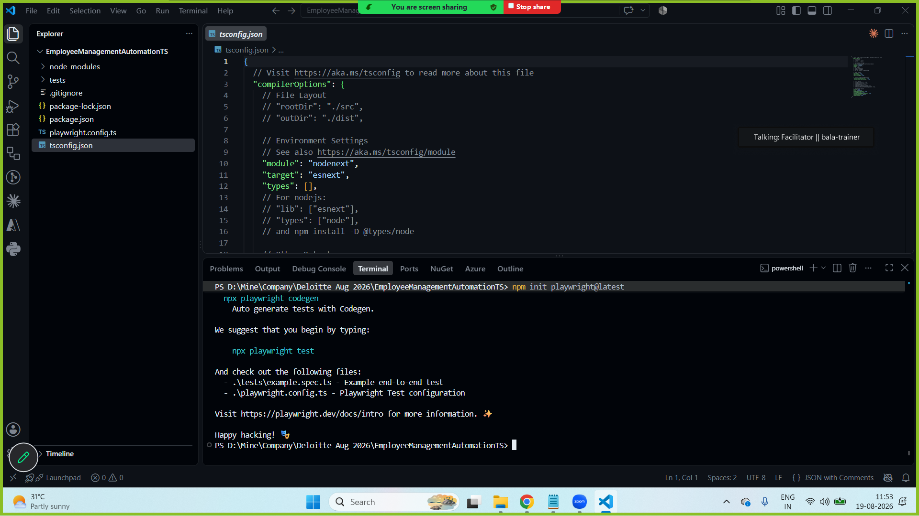
- Update tsconfig.json
"exactOptionalPropertyTypes": false,
"types": ["node"],

- Add extension to run
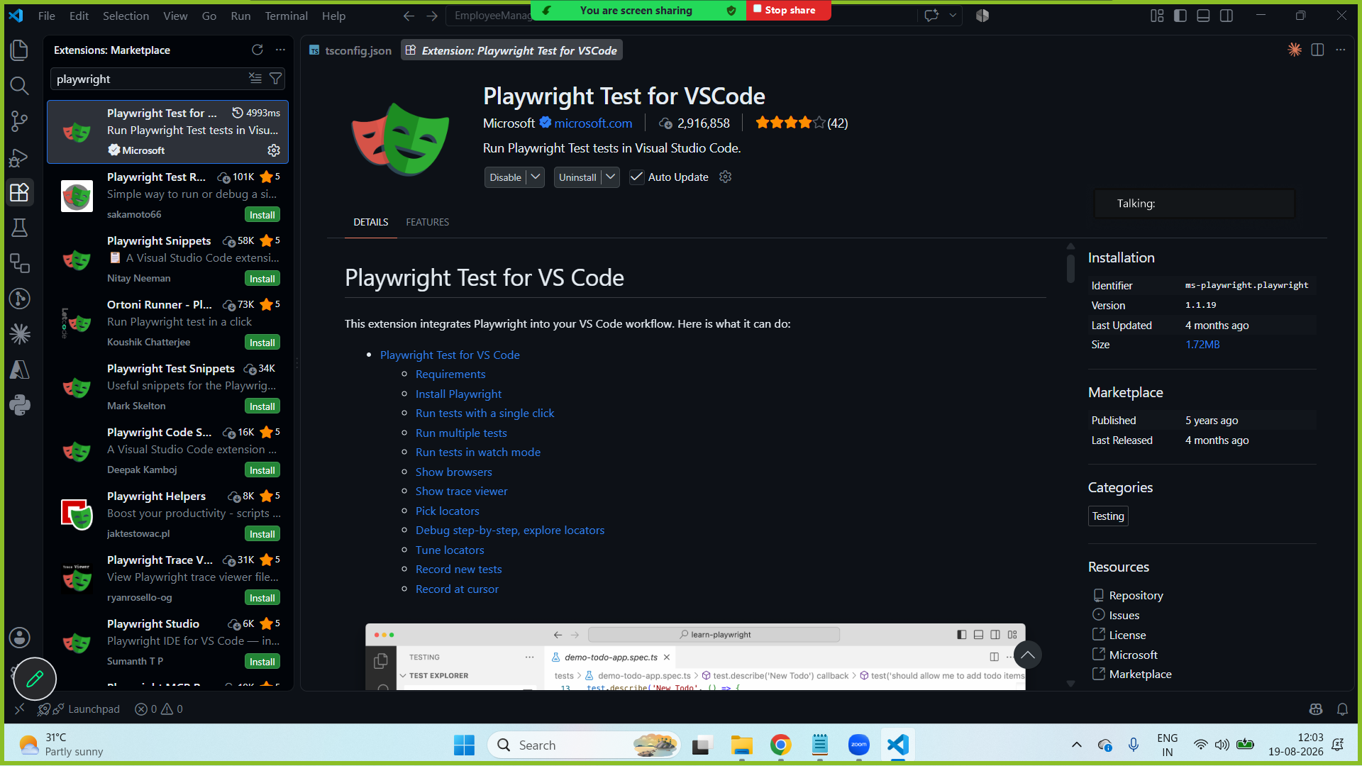

—----------------------------------------------------------------------------------------------------------

—--------------------------------------------------------------------------------------

project 1 - playwright - 1.62.0
.venv --> pip install playwright

Old project - 1.20.0 (running successfully) - on upgrade it is getting failed so I want to run in 1.20.0
.venv --> pip install playwright==1.20.0

System interpreter - C:\Program Files\Python314 (both project uses same python)

-------------------

GitHub API for practice:
https://docs.github.com/en/rest/repos?apiVersion=2022-11-28

- List repositories for a user
- List repositories for the authenticated user
- Create a repository for the authenticated user
- Update a repository
- Delete a repository

Reference

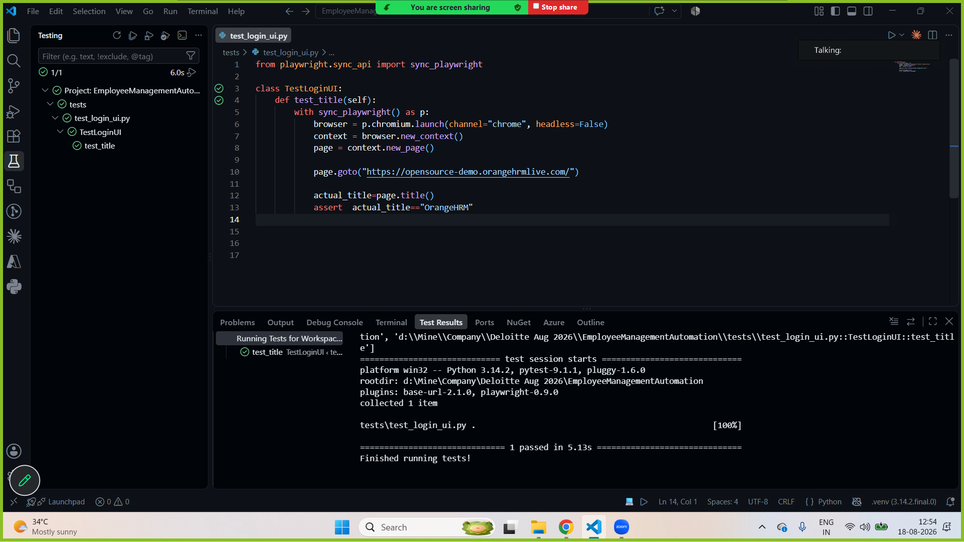

Parallel 1
Session before yield → set up the browser instance (executed only once in the beginning)
Package before yield
Module (.py) before yield
Class before yield
Function before yield → setup context and page
Test method 1
Function after yield -> close page

Function before yield → setup context and page
Test method 2
Function after yield -> close page

Function before yield → setup context and page
Test method 3
Function after yield -> close page
Class after yield
Module (.py) after yield
Package after yield
Session after yield - close the browser (only once at the end of the project execution)

—-------------
Pytest.ini

Parallel - execution
Retry -
Logs
Tags → smoke, regression

—-----------------
